**Corda Network map**

A separate service which provides the configuration about all the nodes which are participating in the network.

* This service is run by Zone Administrator
* Each node is connected to this server using **Compatibility Zone URL**

If this service is not running , it can be statically configured via additional-node-infos

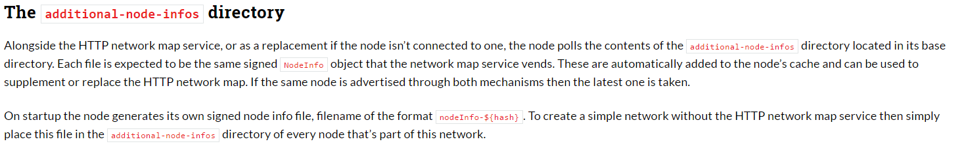

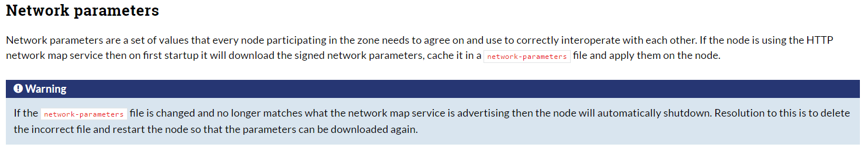

**Usage of Network parameters - without a network map service**

There is the network bootstrapper tool which in addition to generating the network parameters file also distributes the node info files to the node directories

**Network Map – using Cordlite ( non- prod )**

<https://medium.com/corda/cordite-network-map-69e5f2917c8a>

Deploying in normal physical machine